Nama : Rahmatullah Papuadi

NIM : 1207070095

Jurusan : Teknik Elektro C

Matakuliah : Pengolah Citra Digital

Dosen : Rin Rin Nurmalasari

Praktikum 5

* **Operasi Dasar Citra**

1. **Crop**

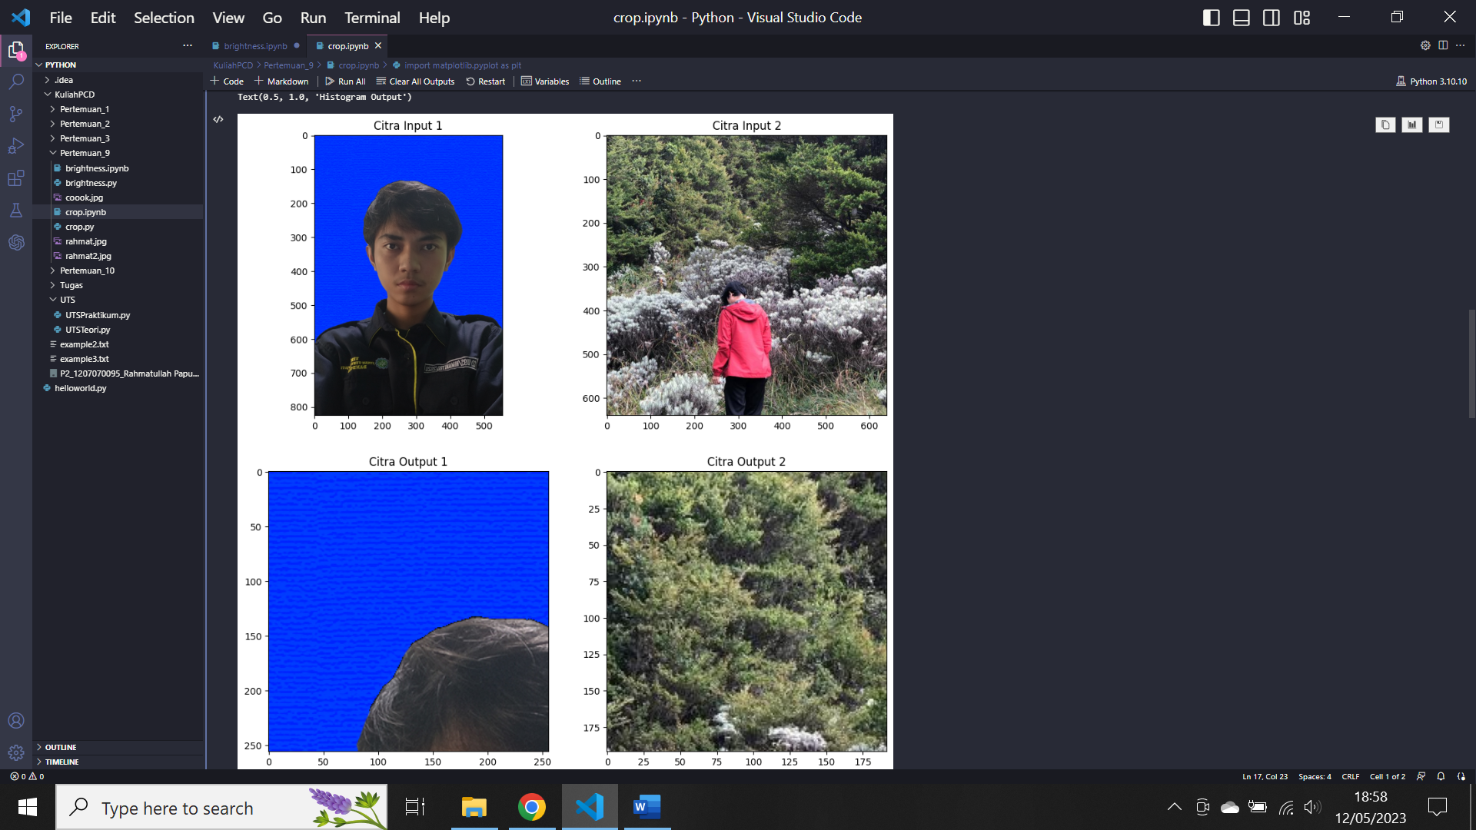

1. **Citra Negatif**

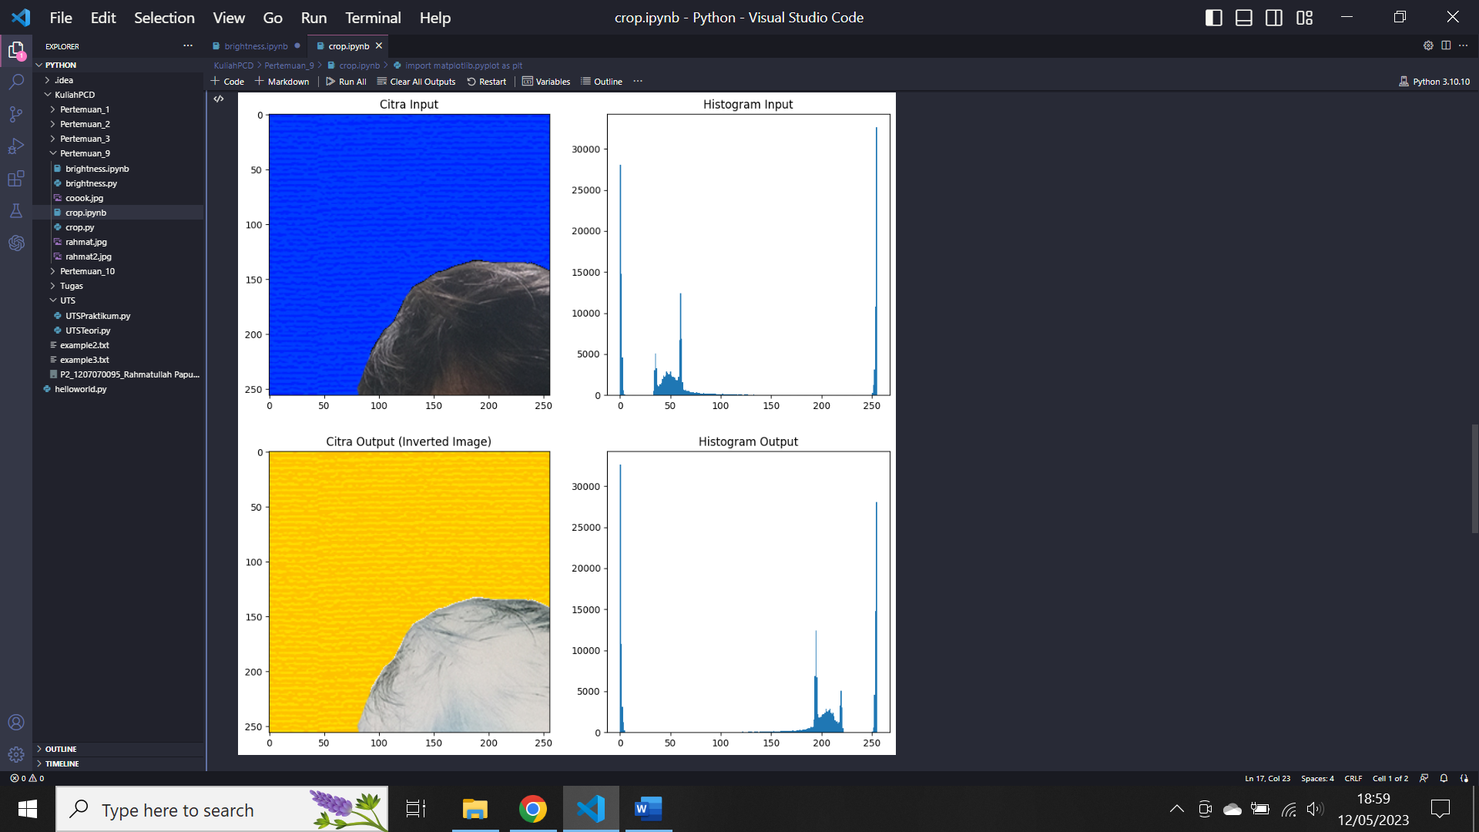

1. **Citra brightness**

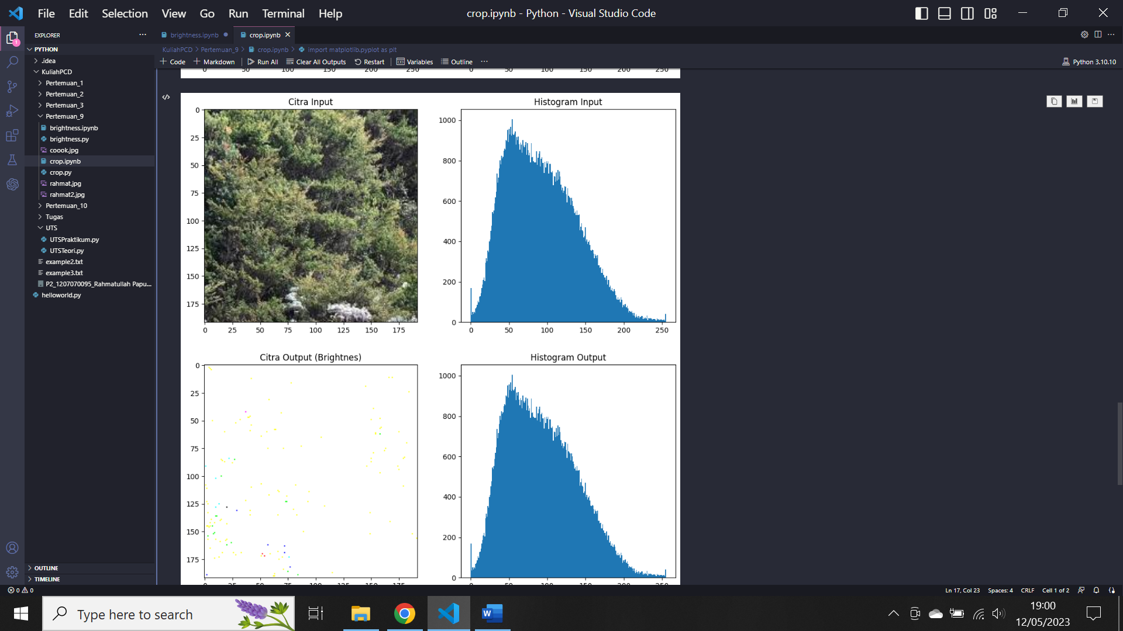

* **Brightness, Contrass, Autolevel Contrass**

1. **Brigtness grayscale**

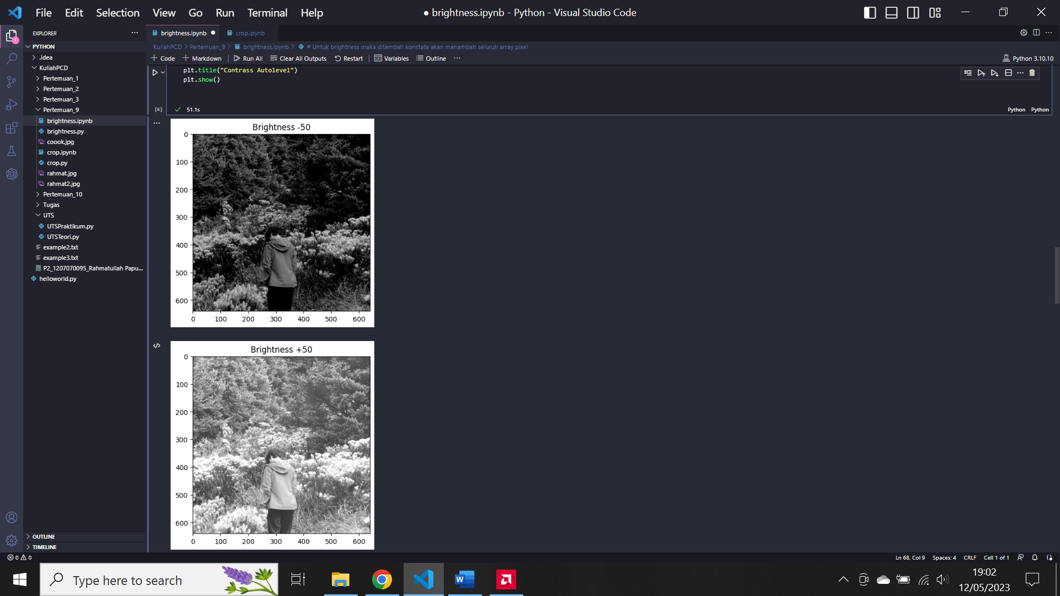

1. **Brightness RGB**

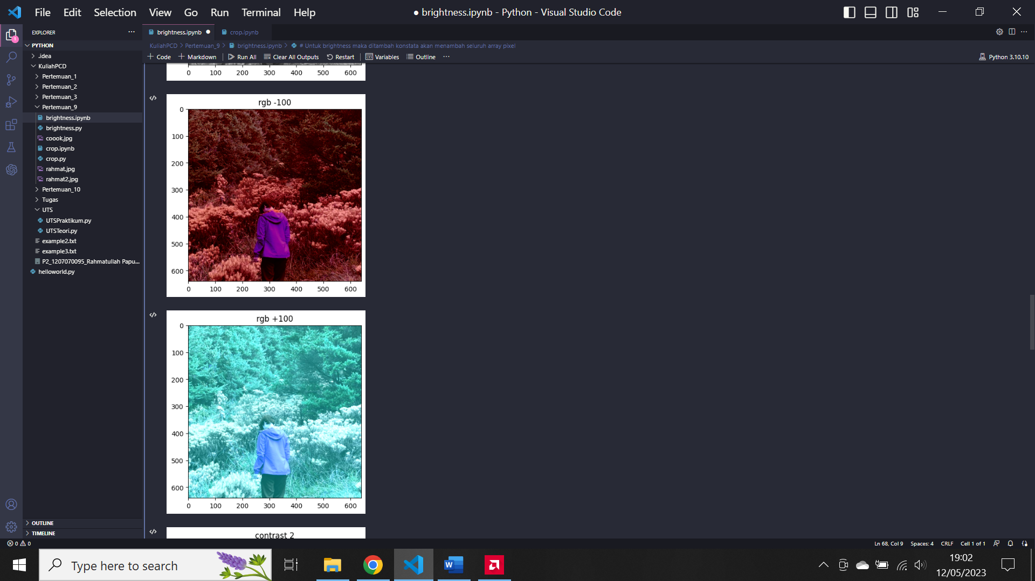

1. Contrass

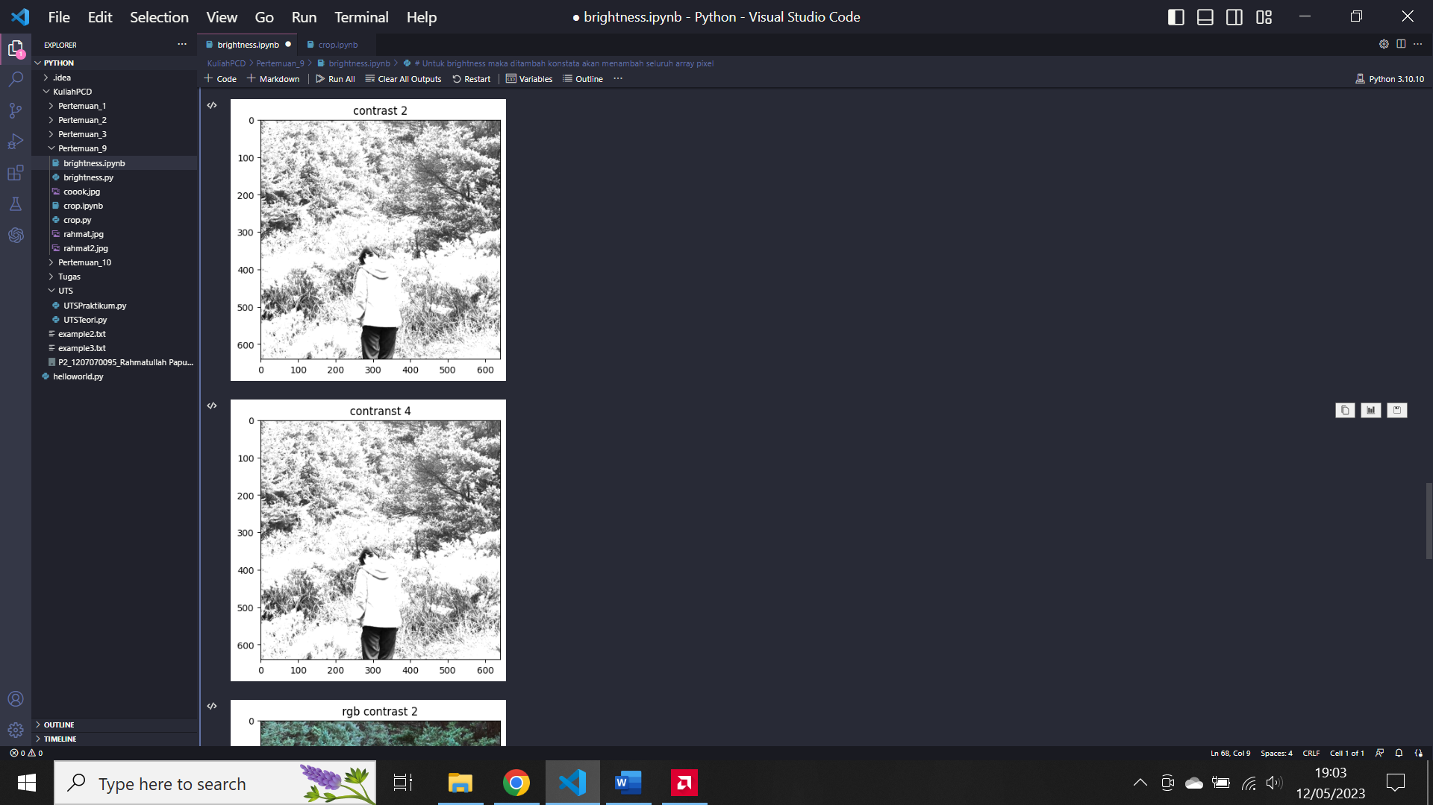

1. RGB Contrass

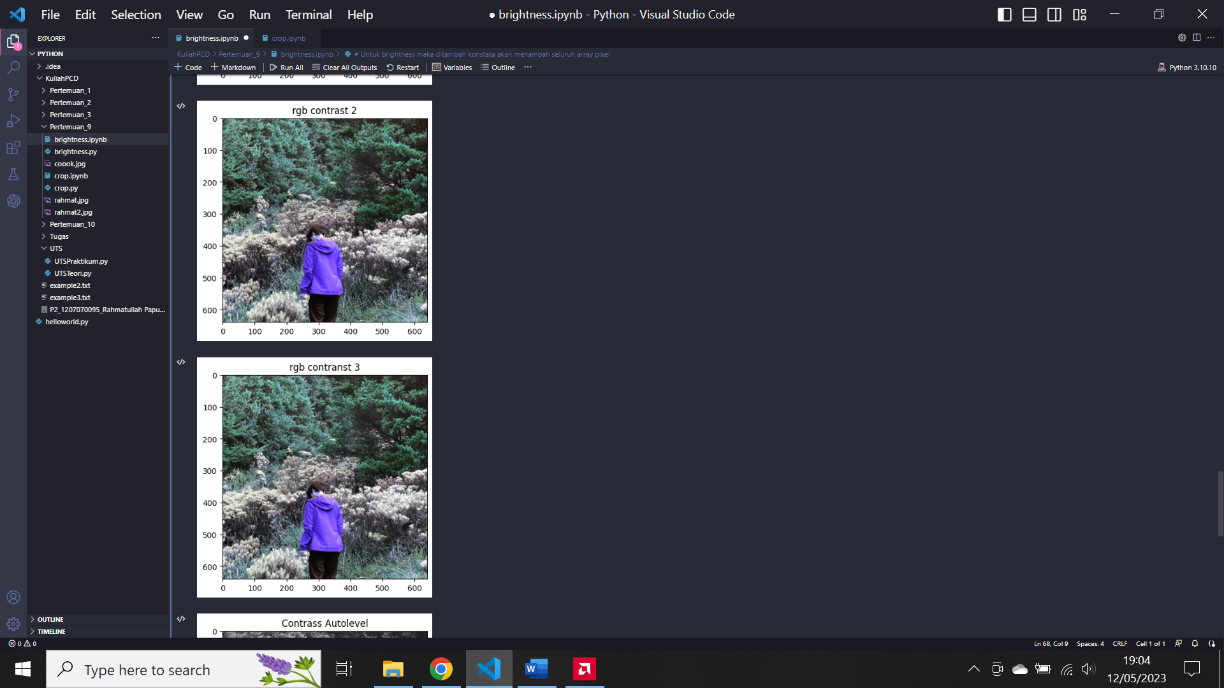5. Contrass Autolevel

